**SPACE FOR LEASE**

**Allen H. Drake Medical Plaza**

1878 W Jeff Road, Suite D

Madison, AL 35758

SELLING – LEASING - MANAGING

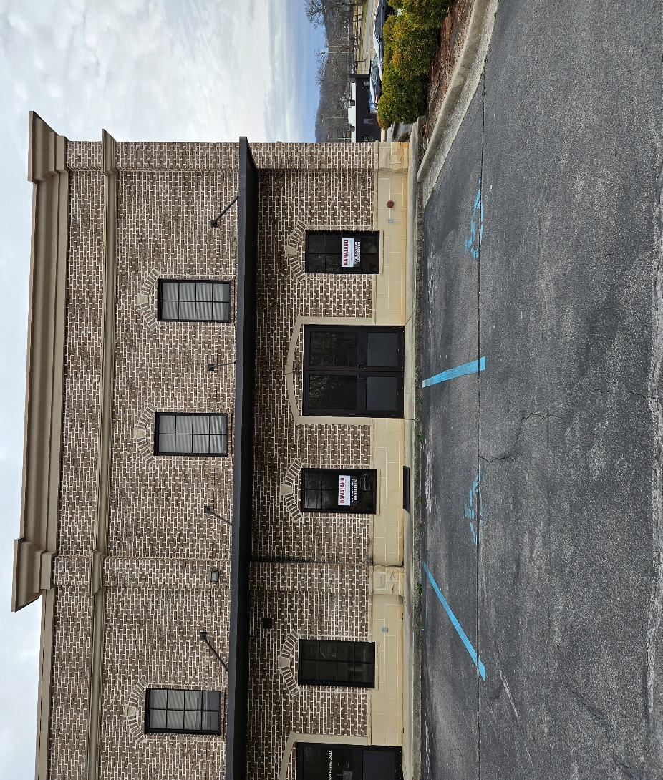

PROPERTY HIGHLIGHTS:

* Building is approximately 17,424 sf
* Available suite is approximately 1,157 sf.
* Suite entrance directly from front sidewalk.
* Drive-up window at side of building.
* Located in Madison County, no zoning.

CONTACT:

**Robert Webber, CCIM**

Robert@PaladinAlabama.com

(256) 682-5831

ANNUAL RENTAL RATE:

**$18.00/sf/yr NNN**

Annual Rent Escalation of 4%

(Estimated Oper. Exp. $4.00/sf/yr)

LOCATION:

Approximately 2 miles south of Hwy 53 and 3.8 miles north of Hwy 72 on Jeff Road in Monrovia.

2311 Market Place, Suite B, Huntsville, AL 35801 – www.PaladinGroupAL.com